Department of Astronomy Teaching Assistant Agreement

Graduate Teaching Assistants are an essential part of a team approach to our Department's education efforts. We seek not only to educate University undergraduates but also to train our graduate students in best-practices of education and science communication. As much as possible the Department expects the lead educator and GTA's to work as partners in fulfilling this mission, making decisions together about pedagogy, classroom management, and content.

Faculty Name: Mathieu Renzo
Teaching Assistant Name: Neev Shah
Course: 180B1 Session 2
Meeting Times: Mon/Wed 2:00-3:15pm
Location: N210
Modality: _in person____________
Class In-Person Meeting Frequency and Format: _2/week_________

We, Mathieu Renzo (faculty) and Neev Shah (TA), met on 08/21/26 (date) to discuss Teaching Assistantship duties for 170B1 002 (course) in Fall 2026 (semester). We have specifically discussed class policies and protocols related to COVID-19. We have agreed to the following:

TA will (check all that apply, and specify whether they are virtual or in-person activities, when applicable):
Top of Form
Bottom of Form

Hold office hours on Wed 1-2pm (date, time, frequency, virtual/in-person)
Attend classes as needed (frequency, or “as needed”, virtual/in-person)
Grade assignments as needed (frequency, or “as needed”)
Grade exams final exam (frequency, or “as needed”)
Teach up to 2 classes throughout the semester (virtual/in-person)
Answer student questions via e-mail
Supervise labs or discussion sections 3 labs (frequency, virtual/in-person)
Design in-class activities, homeworks or labs. (type and number)
Respect all COVID-19 safety guidelines, protocols, and the personal choices and privacy of every class participant regarding COVID-19 situation.
Other

Faculty will (check all that apply):

Observe the TA teaching times throughout the semester and provide feedback
Provide feedback on TA-designed activities/lectures before they are delivered, as long as they are provided 2 days beforehand
Provide a minimum of days for the grading of assignments or exams
Meet with the TA as needed (frequency or “as needed”) to fill them in on upcoming assignments, activities, etc.
Respect all COVID-19 safety guidelines, protocols, and personal choices and privacy of every class participant regarding COVID-19 situation.
Other

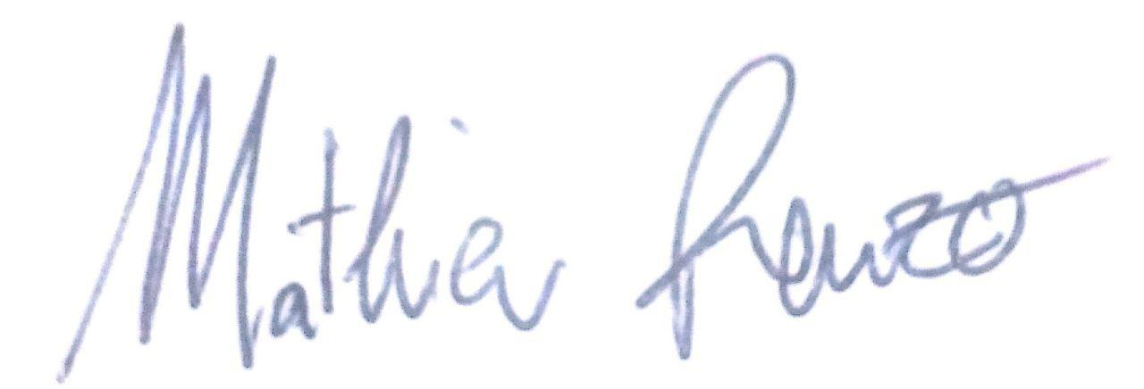
Faculty Signature :
TA Signature : __________________________________________________

This document is meant to serve as a guide to structure TAships. Faculty and TA are welcome to revise this agreement at any point during the semester, and are encouraged to revisit it at the midpoint of the semester.

Note: Per University of Arizona requirements, a TA can be expected to work no more than 20 hours per week on TA duties.

